LinkSprite STM32 Spruce Board Information.

* This is a work in progress

Add to the Arduino IDE

<https://github.com/rogerclarkmelbourne/Arduino_STM32/wiki/Maple-and-Maple-mini>

<https://github.com/rogerclarkmelbourne/Arduino_STM32>

The board is a Leaflabs Maple compatiable (more or less) board, and can be programmed using the Maple R3 from the above boards.

Most of this information doesn’t seem to apply to the board I have, but included.

<http://docs.leaflabs.com/docs.leaflabs.com/index.html>

LinkSprite Spruce

The LinkSprite Spruce STM32 Cortex board can be used with OpenJTAG and is compatible with mini ARM cortex-M3 board. Thei board is compatible with Arduino, Maple and OLIMEXINO-STM32. Spruce has Arduino compatible shield pins, all the Arduino shields can be used on LinkSprite STM32 cortex board. The Spruce also programs with a similar IDE that can be used to download Arduino code to Spruce board.

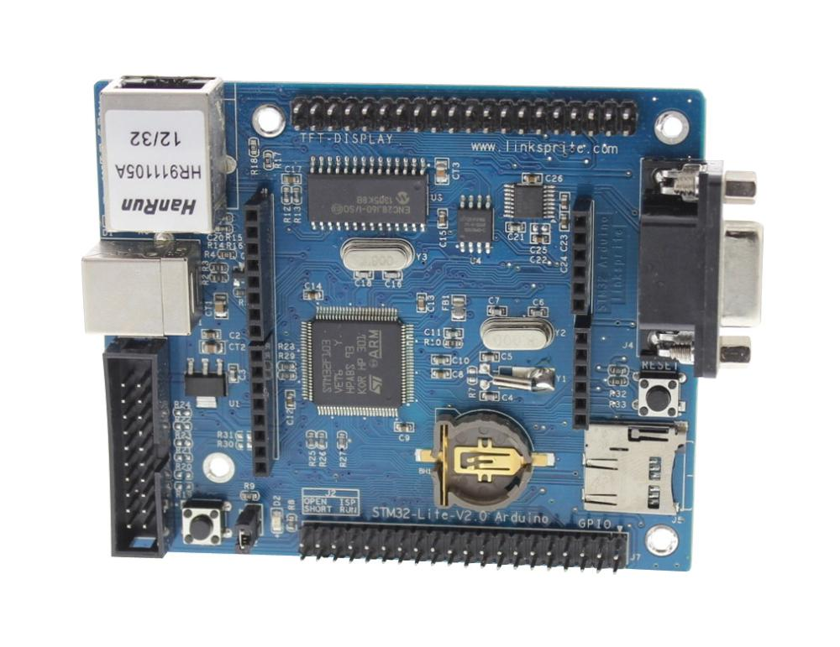

The Spruce boards are designed to be Arduino compatible and not just at the hardware level ! The Spruce IDE will make Arduino programmers feel right at home. By swapping the popular "avr-gcc" compiler with CodeSourcery's "arm-non-eabi-gcc", LeafLabs manages to provide a nearly identical programming experience to Arduino despite targeting a completely different architecture.

Spruce has Arduino compatible pinout meaning that all the Arduino shields can be used on the LinkSprite Spruce STM32 cortex board.

Features:

* CPU: STM32F103VET6 using a TQFP 100 pin package with 512K BYTES flash and 64KBYTES SRAM
* 1 JTAG debug interface
* 1 power LED indicattor (Green), 1 status LED (Blue)
* 1 RS232 port, Need crossover cable to talk to PC
* Support 3 pin ISP
* 1 USB 2.0 SLAVE port
* 1 Micro SD(TF) slot, uses SDIO
* 1 SPI interfaced AT45DB161D(2M BYTES) serial FLASH
* 1 functional button
* 1 RTC battery socket
* 1 RJ45 Ethernet port
* All unused GPIO pins are connected to external headers.

Linksprites Wiki Page:

<http://linksprite.com/wiki/index.php5?title=Spruce>

Soliddigi Spruce Info Pages: (Appear to be more helpful than the Linksprite pages)

<http://www.soliddepot.com/spruce/>

Soliddigi STM32-Lite-V2 Page (This is the board I own):

<http://www.soliddepot.com/spruce/hardware/maple-ret6.html>

Other Information:

This section lists the Spruce STM32 Arduino Edition’s [*board-specific values*](http://www.soliddepot.com/spruce/lang/api/board-values.html#lang-board-values).

* CYCLES_PER_MICROSECOND: 72
* BOARD_BUTTON_PIN: 34
* BOARD_LED_PIN: 4
* BOARD_NR_GPIO_PINS: 44 (however, [*pin D43 is not usable*](http://www.soliddepot.com/spruce/hardware/maple.html#maple-nrst-pb4))
* BOARD_NR_PWM_PINS: 18
* boardPWMPins: 0, 1, 2, 3, 5, 6, 7, 8, 9, 11, 12, 14, 24, 27, 28, 35, 36, 37
* BOARD_NR_ADC_PINS: 15
* boardADCPins: 0, 1, 2, 3, 10, 11, 12, 15, 16, 17, 18, 19, 20, 27, 28
* BOARD_NR_USED_PINS: 7
* boardUsedPins: BOARD_LED_PIN, BOARD_BUTTON_PIN, BOARD_JTMS_SWDIO_PIN, BOARD_JTCK_SWCLK_PIN, BOARD_JTDI_PIN, BOARD_JTDO_PIN, BOARD_NJTRST_PIN
* BOARD_NR_USARTS: 3 (unfortunately, [*due to the Maple Rev 5 design*](http://www.soliddepot.com/spruce/hardware/maple-ret6.html#maple-ret6-uarts), UARTs 4 and 5 have pins which are not broken out).
* BOARD_USART1_TX_PIN: 7
* BOARD_USART1_RX_PIN: 8
* BOARD_USART2_TX_PIN: 1
* BOARD_USART2_RX_PIN: 0
* BOARD_USART3_TX_PIN: 29
* BOARD_USART3_RX_PIN: 30
* BOARD_NR_SPI: 2 (unfortunately, [*due to the Maple Rev 5 design*](http://www.soliddepot.com/spruce/hardware/maple-ret6.html#maple-ret6-nrst-pb4), SPI3 is unavailable).
* BOARD_SPI1_NSS_PIN: 10
* BOARD_SPI1_MOSI_PIN: 11
* BOARD_SPI1_MISO_PIN: 12
* BOARD_SPI1_SCK_PIN: 13
* BOARD_SPI2_NSS_PIN: 31
* BOARD_SPI2_MOSI_PIN: 34
* BOARD_SPI2_MISO_PIN: 33
* BOARD_SPI2_SCK_PIN: 32
* BOARD_JTMS_SWDIO_PIN: 39
* BOARD_JTCK_SWCLK_PIN: 40
* BOARD_JTDI_PIN: 41
* BOARD_JTDO_PIN: 42
* BOARD_NJTRST_PIN: *[43](http://www.soliddepot.com/spruce/hardware/maple-ret6.html#maple-ret6-nrst-pb4)*

Stuff That I have learned:

Serial1 is connected to the 9 pin RS232 port, the adapter I used didn’t need a null modem.

User LED is on Pin D4

The user button needs to be held in after a RESET to program the board.

So far I’ve not seen a USB - Serial port show up, and I’m not sure how to get the USB Serial to work.